|  |  |
| --- | --- |
| **شعار جامعة بنها الجديد** | **logo.jpg** |
| **Benha University** | **Faculty Of Computers &**  **Information** |

Auto Intensity Control

of Street Lights

Team Members :

**-**Yassmen AbdElazez (14)

**-**Noha Emad Sayed (14)

-Nada Mohamed Mohamed Abdo (13)

**Supervisor:**

**Dr.walaa mohamed**

**Prof. Tarek Ahmed Al-sheshtawy**

|  |
| --- |
| **Table of Contents** |
| **1. Introduction**  1.1 Purpose  1.2Overview  1.3 Project Scope  1.4 references |
| **2. The Overall Description**  2.1 Product Perspective    2.2 Product Features  2.3 Use Cases  2.3.1 Use Case 1  2.3.2 Use Case 2  2.3.3 Use Case 3  2.3.4 Use Case 4  2.3.5 Use Case 5  2.4 State Diagram  2.5 Data Flow Diagram  2.6 Context Diagram  2.7 Level-0 Diagram  2.8 Sequence Diagram  2.8.1 generic sequence diagram  2.8.2 System OFF  2.8.3 System ON  2.9 Class Diagram  2.10 object Diagram  2.11 Activity Diagram |
| **3. Hardware Requirements**  3.1 Introduction  3.2 MicroController  3.3 PIR Sensor  3.4 DS1307 IC  3.5 LDR  3.6 LCD  3.7 LED  **4. Software Requirements**  4.1 Maintenance Requirements  4.2 Repair ability  4.3 Performance Requirements  4.4 Safety  **5. Tables and Description** |

5.1 state Description

**6. Summary**

**Table of Figures**

**Figure (1) real circuit of the system**

**Figure (2) circuit diagram**

**Figure (3) PIR sensor**

**Figure (4) LDR**

**Figure (5) LCD**

**Figure (6) PIN INFORMATION OF THE LCD**

**This project solve this problem**

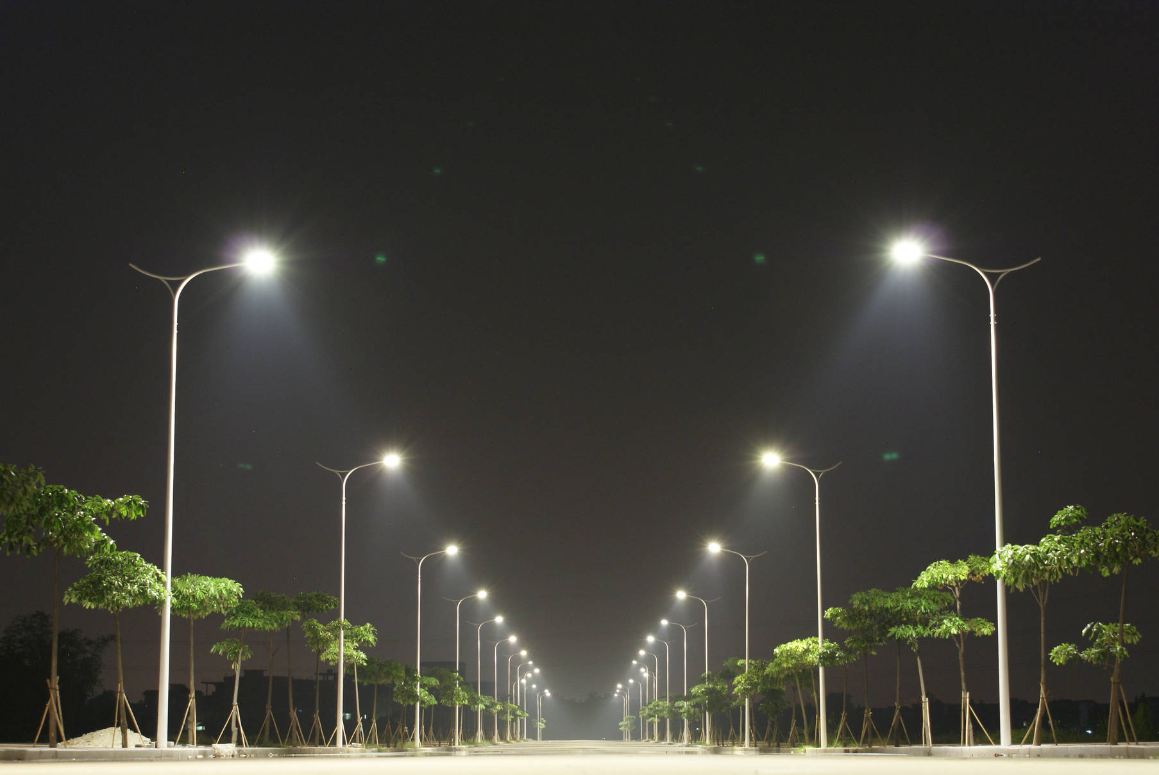

1. **Introduction :**

Automation, Power consumption and Cost Effectiveness are the important considerations in the present field of electronics and electrical related technologies. Industry of street lighting systems are growing rapidly and going to complex with rapid growth of industry and cities.

* 1. **Purpose :**

The purpose of this document is to specify the requirements and preview some elements of the analysis model of the system , generally, street lights are switched on for whole night and during the day, they are switched off. But during the night time, street lights are not necessary if there is no traffic. Saving of this energy is very important factor these days as energy resources are getting reduced day by day. Alternatives for natural resources are very less and our next generations may face lot of problems because of lack of these natural resources.

**1.2Overview :**

1. **Introduction:** Provide an overview of the System ,describe the document structure and point the individual objectives.
2. **Overall Description:** Provide the specification of the system model ,the classes moden, Diagrams ,the main constraints and the list any assumed factors that used within this document.
3. **System Features** : Provide the analysis of the requirements by feature.

**4. External Interface Requirements :** Provide the visualization of the program and the requirements that are related with hardware ,software and networking.

**5. Other Nonfunctional Requirements :** Provide some other constraints that apply to factors such as performance ,safety and security.

**1.3Project Scope :**

Street lights are switched on depending on the intensity of the Sun light on LDR. If the intensity of Sunlight on light dependent resistor is low, its resistance value is high. This value increases and becomes high when it is completely in the dark. This resistance value decides when the street lights are required to switch ON.

As the resistance value is maximum in the midnights, real time clock comes into the play. The controller checks peak time during which there is no traffic and switch OFF the lights. When there is any vehicle on the road, it is detected by the PIR sensor.

Whenever PIR sensor is detected it just - the microcontroller to switch on the street lights. Then lights are switched on for 2 to 3 minutes and switched off automatically.

Another way to this approach is, one can maintain minimum intensity without completely switching off the lights and switch them on to maximum intensity whenever it detects the vehicle. But in this system the circuit is designed in such a way that lights are completely switched OFF and will be switched ON only when there is any vehicle.

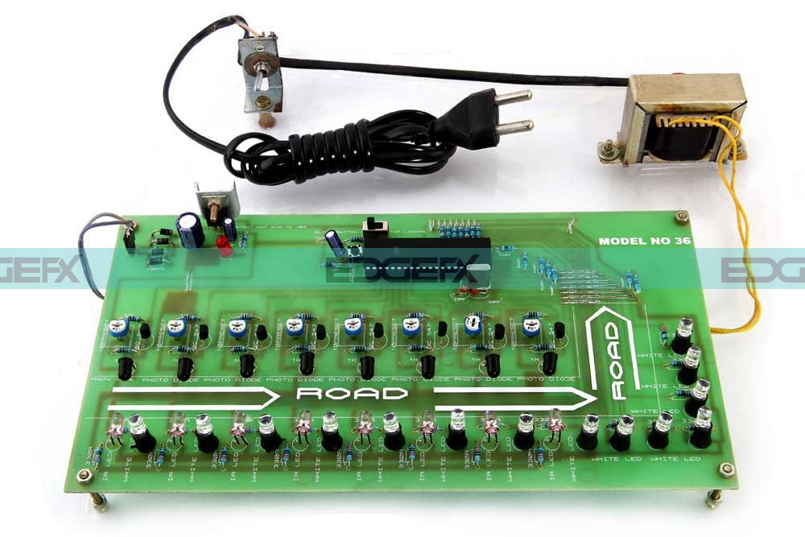

Fig(1)

**1.4References :**

|  |
| --- |
| **URL** |
| <https://www.electronicshub.org/?s=Auto+Intensity+Control+of+Street+Lights>+ |
| <https://www.ieee.org/> |
| <http://selfabhyas.blogspot.com/2016/05/auto-intensity-control-of-street-lights.html> |

**2.Overall Description :**

**2.1- Product Perspective**

There are various reasons why should Organizations and governments use this system, first This circuit uses LED Bulbs, so it is very low cost and it has more life span. Second , Maximum energy can be saved, This can be used for lights in parking areas of industries, hotels, restaurants, etc.

**2.2- Product Features**

The major features this system contains are the following:

* A street light that automatically switches ON when the night falls , and turns OFF when the sun rises
* In fact, we can use this circuit for implementing any type of automatic night light
* The circuit uses a LDR to sense the light

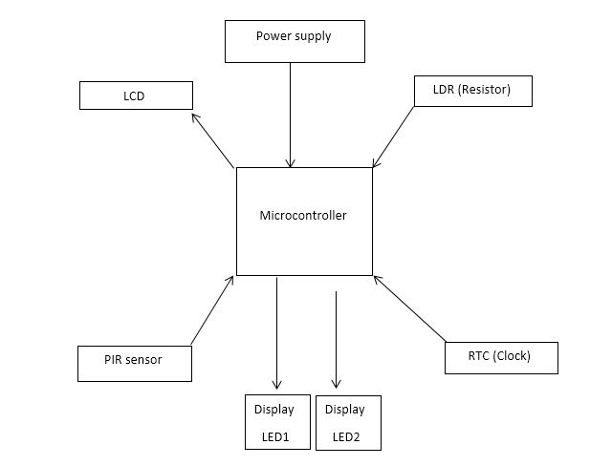

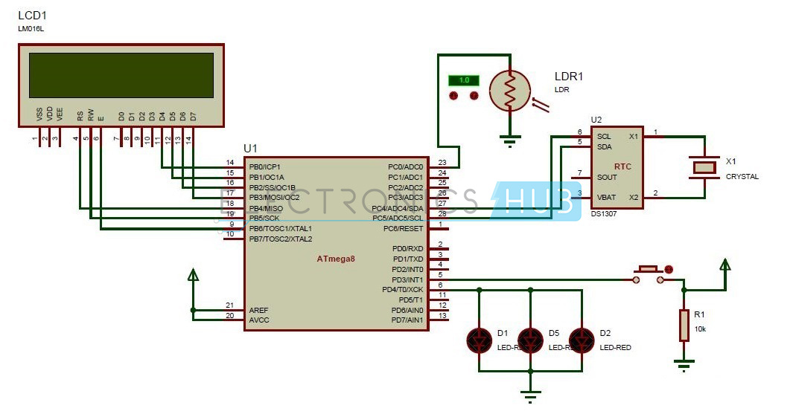

Circuit diagram Fig(2)

#### ****How to Operate this Circuit?****

1. Initially power the circuit.
2. LCD displays the time read from RTC.

* check the time if the time is between 9 pm to 2 am street light glows with full intensity.

1. Place the LDR in darkness. Now street light is switched ON.
2. Now micro controller continuously checks the time. Street Light is switched on for fixed timings written in the code.
3. After this time, they are switched off automatically.
4. Place your hand in front of PIR sensor, this switches the street lights again, indicating that on the detection of any object street light is ON.
5. After 2-3 minutes delay, lights are again switched off automatically.

**2.3 Use Case :**

**Use Case List :**

|  |  |  |
| --- | --- | --- |
| **Use Case ID** | **Primary Actor** | **Use Cases** |
| UC-1  UC -2  UC -3  UC -4  UC -5 | Car / vehicle  LED  PIR  Clock  Microcontroller  LDR | System on  System of  LED  PIR Sensor  Clock |

**2.3.1-Use Case(s) :**

|  |  |  |
| --- | --- | --- |
| **Use Case ID:** | UC-1 | |
| **Use Case Name:** | System is on | |
| **Actors:** | | - Car/ vehicle, PIR, microcontroller, LDR,LED |
| **Preconditions:** | | System is off |
| **Post-conditions:** | | 1. system is on 2. Street lights will glow with a specific intensity if there's a car crossed. |
| **Normal Flow:** | | 1. If vehicle passes on read. 2. PIR sensor sending signal to microcontroller. 3. Then microcontroller will check the value of resistor. 4. at the night the value of LDR resistor is high. 5. so the microcontroller will order the street lights to glow with specific intensity. |
|  | |  |
| **Frequency of Use:** | | on demand |

**2.3.2-Use Case(s):**

|  |  |  |
| --- | --- | --- |
| **Use Case ID:** | UC-2 | |
| **Use Case Name:** | System is off | |
| **Actors:** | | - Car/ vehicle, PIR, microcontroller, LDR,LED |
| **Preconditions:** | | System is on |
| **Post-conditions:** | | 1. system is off 2. Street lights will not glow if there's anything crossed. |
| **Normal Flow:** | | 1. PLR sensor sending signal to microcontroller. 2. Then microcontroller will check the value of resistor. 3. when sun rises the value of LDR resistor decreases. 4. so the microcontroller will order the street lights to not glow at day time.   5.or system is off if time after 2 am and and only on If vehicle passes on read. |
|  | |  |
| **Frequency of Use:** | | on demand |

**2.3.3-Use Case(s) :**

|  |  |  |
| --- | --- | --- |
| **Use Case ID:** | UC-3 | |
| **Use Case Name:** | LED | |
| **Actors:** | | - LED |
| **Preconditions:** | | The state of LED is off |
| **Post-conditions:** | | Changing its state from off to on or stay off |
| **Normal Flow:** | | 1. The microcontroller will check the value of resistor 2. If LDR resistor is high ,LED will glow. 3. If LDR resistor is low ,LED will not glow.   4.And If vehicle passes on read after 2 am. |
|  | |  |
| **Frequency of Use:** | | on demand |

**2.3.4-Use Case(s) :**

|  |  |  |
| --- | --- | --- |
| **Use Case ID:** | UC-4 | |
| **Use Case Name:** | PIR sensor | |
| **Actors:** | | - PIR sensor |
| **Preconditions:** | | PIR sensor is off |
| **Post- conditions:** | | PIR Sending signal to microcontroller |
| **Normal Flow:** | | 1. Vehicle is passing. 2. Sensor sends signal to microcontroller. 3. Microcontroller receive signals and send order to LED to glow or not. |
|  | |  |
| **Frequency of Use:** | | on demand |

**2.3.5 -Use Case(s) :**

|  |  |  |
| --- | --- | --- |
| **Use Case ID:** | UC-5 | |
| **Use Case Name:** | Clock | |
| **Actors:** | | Clock |
| **Preconditions:** | | The value of resistance is high |
| **Post- conditions:** | | Measure the time form clock and turn on the LED with specific intensity according to the time |
|  | |  |
| **Normal Flow:** | | 1. 1. If vehicle passes on road. 2. PLR sensor sending signal to microcontroller. 3. Then microcontroller will check the value of resistor. 4. If the value of LDR resistor is high.   5.Then check the time , if the time from 9PM to 2AM turn on LED after 2am turn off and use PIR to Detect any vehicle pass. |
| **Frequency of Use:** | | on demand |

* 1. **State Diagram :**

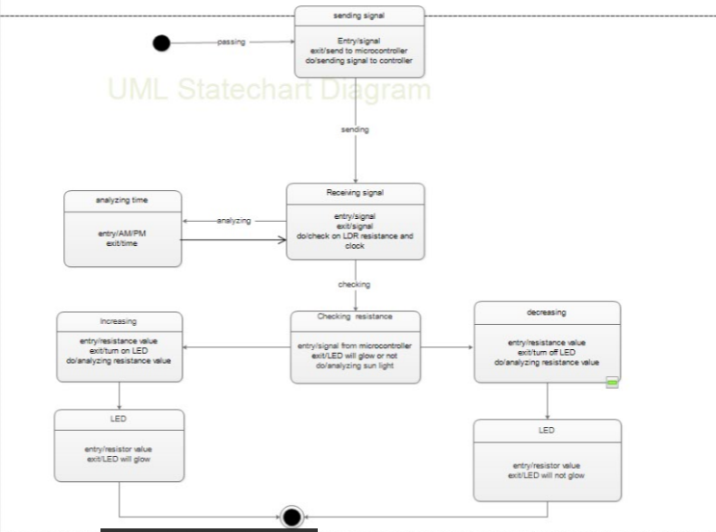

**2.5 Data Flow Diagram :**

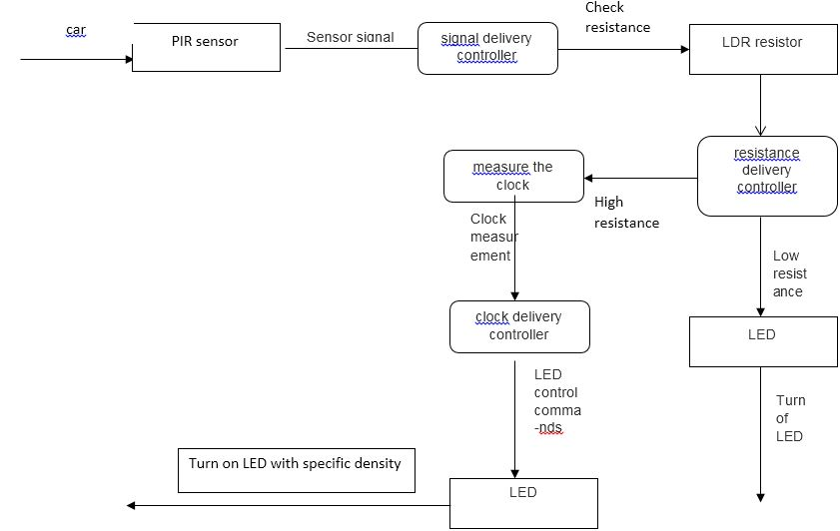

* 1. **Context Diagram :**

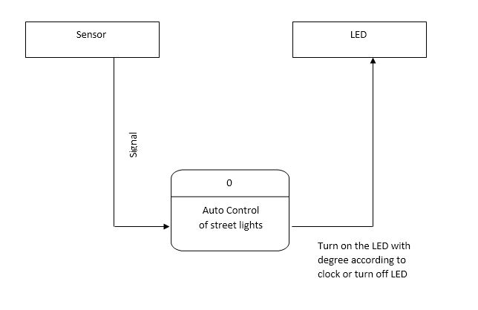

* 1. **- Level-0 Diagram :**

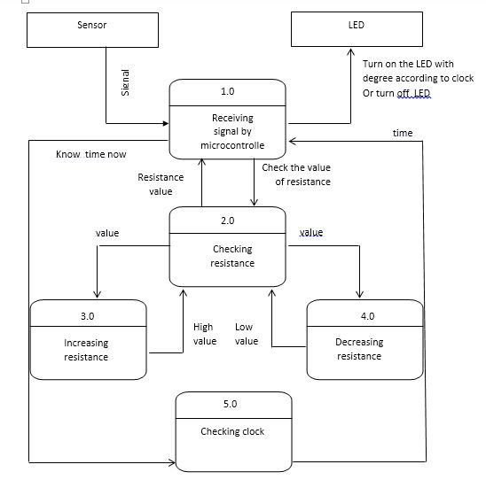

* 1. **Sequence Diagram :**
     1. **Generic sequence diagram :**

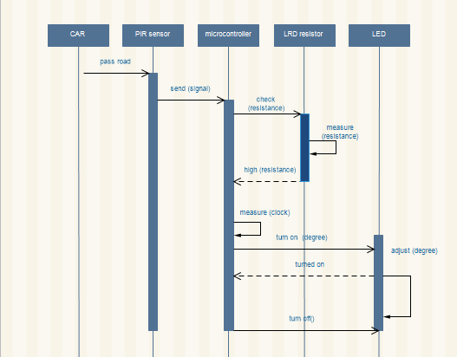

* + 1. **System OFF :**

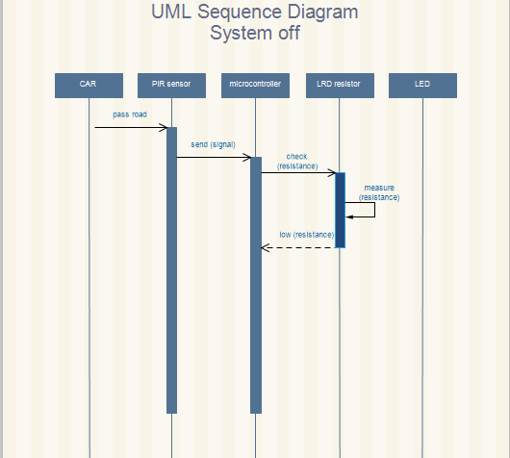

* + 1. **System ON :**

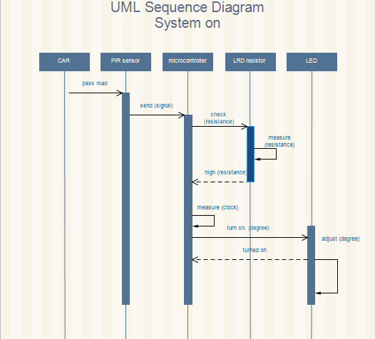

* 1. **Class Diagram :**

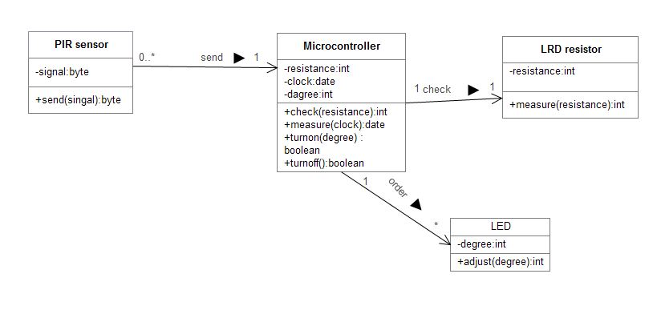

**2.10 Object Diagram :**

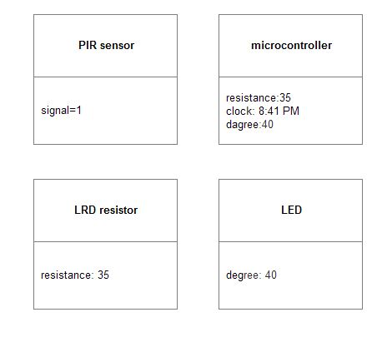

**2.11 Activity Diagram :**

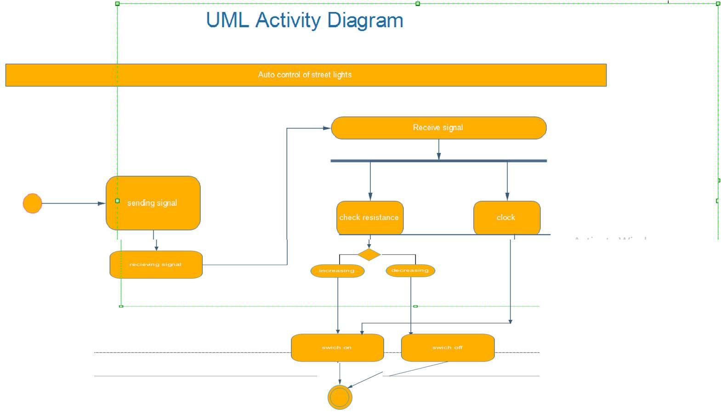

1. **Hardware Requirements**
   1. **- Introduction :**

**Circuit Components:**

* Microcontroller
* DS1307 IC
* PIR sensor
* LDR
* LCD
* LED
  1. **- MicroContoller :**

This section provides an introduction to most common word in the embedded system “microcontroller”. It is written to familiarize you with microcontroller terminology and basic microcontroller architecture. A microcontroller is a single chip, self-contained computer which incorporates all the basic components of a personal computer on a much smaller scale. Microcontrollers are often referred to as single chip devices or single chip computers. The main consequence of the microcontroller’s small size is that its resources are far more limited than those of a desktop personal computer. In functional terms, a microcontroller is a programmable single chip which controls a process or system. Microcontrollers are typically used as embedded controllers where they control part of a very larger system such as an appliance, automobile, scientific instrument or a computer peripheral.

Microcontrollers are designed to be low cost solutions; therefore using them can drastically reduce part and design costs for a project. Physically, a microcontroller is an integrated circuit with pins along each side. The pins presented by a microcontroller a reused for power, ground, oscillator, I/O ports, interrupt request signals, reset and control .In contrast, the pins exposed by a microprocessor are most often memory bus signals

**A microcontroller has seven main components:**

1. Central processing unit (CPU).
2. ROM.
3. RAM.
4. Input and Output.
5. Timer.
6. Interrupt circuitry.
7. Buses
   1. **-PIR Sensor :**

Passive Infrared sensor, also called as PIR sensor is connected to the PD0 pin of the microcontroller. PIR sensor senses the motion of the objects.

The PIR sensor internally will have an IR detector. Every object in the world radiates some IR rays. These are invisible to the human eye but electronic components can detect them. Different objects will emit IR rays of different wavelength. These rays were detected by the PIR sensor. PIR is initially high and is set to low automatically after sometime. Whenever it detects the motion of any object, it becomes low.

The PIR sensor itself has two slots in it, each slot is made of a special material that is sensitive to IR

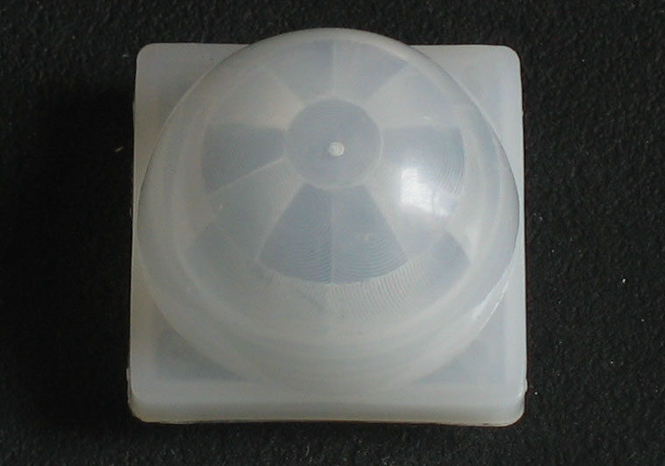

PIR Sensor Fig(3)

* 1. **- DS1307 IC :**

Real-Time Clock Counts Seconds, Minutes, Hours, Date of the Month, Month, Day of the Week, and Year with Leap-Year Compensation Valid Up to 2100

Real time clock IC used is DS1307, which is I2C compatible. Real time clock has 8 pins.1 and 2 pins are connected to the crystal oscillator.3rd pin is connected to a battery.6th pin of RTC is connected to PC5 pin of microcontroller.5th pin is connected to PC4 pin of microcontroller.

I2C is inter integrated circuit. This is two wire interface protocol in which only two signals were used to transmit the data between two devices.

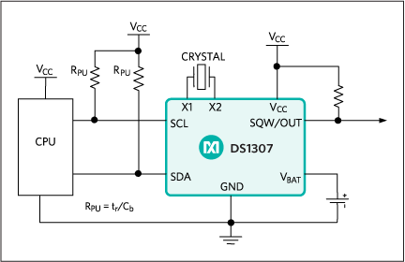

* 1. **LDR :**

LDRs or Light Dependent Resistors are very useful especially in light/dark sensor circuits. Normally the resistance of an LDR is very high, sometimes as high as 1000000ohms, but when they are illuminated with light resistance drops dramatically. Electronic onto sensors are the devices that alter their electrical characteristics, in the presences of visible or invisible light. The best-known devices of this type are the light dependent resistor (LDR), the photo diode and the photo transistors. Light dependent resistor as the name suggests depends on light for the variation of resistance.

* Automatic street lights on & off using light dependent resistor
* LDR are made by depositing a film of cadmium sulphide or cadmium selenide ona substrate of ceramic containing no or very few free electrons when not illuminated .The longer the strip the more the value of resistance.

When light falls on the strip, the resistance decreases. In the absence of light the resistance can be in the order of 10K ohm to 15K ohm and is called the dark resistance

Depending on the exposure of light the resistance can fall down to value of 500ohms. The power ratings are usually smaller and are in the range 50mw to .5w. Though very sensitive to light, the switching time is very high and hence cannot be used for high frequency applications. They are used in chopper amplifiers. Light dependent resistors are available as discs 0.5cm to 2.5cm. The resistance rises to several Mega ohms under dark conditions.

The LDR is a variable resistor whose resistance decreases with the increase in light intensity. Two cadmium sulphide (cds) photoconductive cells with spectral response similar to that of the human eye. The cell resistance falls with increasing light intensity .some of its features:

•High reliability.

•Light weight



Fig(4)

* 1. **-LCD :**

In the recent years the LCD is finding widespread use replacing LEDS, seven segment display. This is due to the declining prices of LCDS the ability to display numbers, characters, and graphics. This is in contrast to LEDS, which are limited to numbers and a few characters. Incorporation of a refreshing controller into LCD, there by relieving the CPU of the task of refreshing the LCD in contrast the LED must be refreshed by the CPU to keep displaying the data ease of programming for characters and graphics

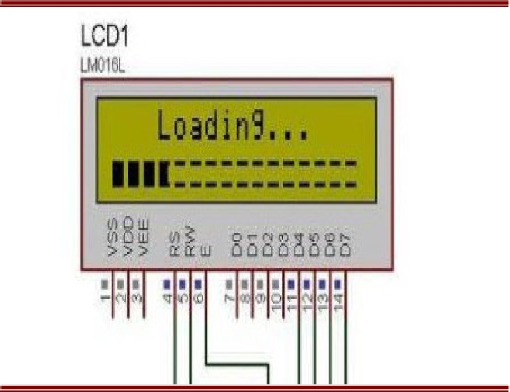

**Fig(5)**

**PIN INFORMATION OF THE LCD :**

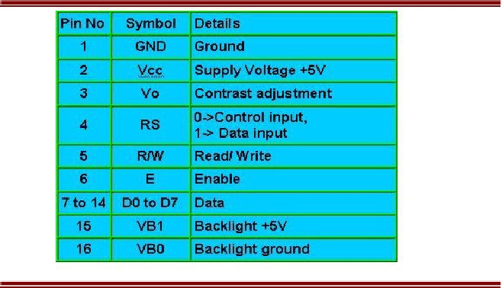

**Fig(6)**

The hardware interfacing of the LCD pins and discussed below:

The LCD has 16 pins.

•The first pin is connected to the ground.

•The second pin is connected to the VCC.

•The third pin is the contrast pin and it is connected to the potentiometers middle pin. (Potentiometer has three pins). The other two pins of the potentiometer are connected to the vcc and ground.

•The fourth pin is the RS pin and it is connected to the 37 Th pin of the microcontroller.

• The fifth pin is RW pin and it is connected to the 38 TH pin of the microcontroller.

• The sixth pin is the enable pin and it is connected to the 39 TH pin of the microcontroller.

* 1. **-LED :**

An LED lamp is a light-emitting diode (LED) product that is assembled into a lamp (or light bulb) for use in lighting fixtures. LED lamps have a lifespan and electrical efficiency LED lighting differs from incandescent and compact fluorescent lighting in several ways. When designed well, LED lighting can be more efficient, durable, versatile and longer lasting.

**LED lighting** products use light emitting diodes to produce light very efficiently. An electrical current passes through semiconductor material, which illuminates the tiny light sources we call LEDs. The heat produced is absorbed into a heat sink.

1. **Software Requirements :**
   1. **Maintenance Requirements :**

There is no statutory obligation to provide street lighting. However, all local authorities have a duty of care to ensure highway electrical equipment is maintained in a safe condition. All systems of public lighting will be maintained to a standard that ensures its safe, economic and effective operation.

The maintenance of an up-to-date electronic-based inventory of all units to ensure satisfactory management of the maintenance process, and to enable the annual assessment of the energy charge to be obtained, is vital.

* 1. **Repairability :**

Reflects the extent to which the system can be repaired in the event of a failure

**4.2.1 Fault Detection :**

Fault detection is carried out by use of a computerized management system which allows for remote monitoring and reporting of defects.

**4.2.2 Fault Repairs:**

|  |  |
| --- | --- |
| Emergency Fault attendance | Two Hours |
| Urgent Fault attendance  Ex: multiple lamp failures, faults at accident black-spots , etc | Twenty-Four Hours |
| Non-Emergency Fault attendance | Three Business Days |

* 1. **Performance requirements :**

Note that in the installed base or stock of street lighting, older equipment do not necessarily meet these relatively new performance requirements e.g. lighting level, uniformity etc..

Because the number of classes specified in the standard is relatively extensive, a simplified and more aggregated classification of 3 road categories

These categories with the same lighting levels and more corresponding with the classes used in European statistics for road lengths are defined hereafter:

1. Category F “fast traffic” with fast motorized traffic use only .
2. Category M “mixed traffic” with motorized traffic, slow moving vehicles, and possibly cyclists and pedestrians .
3. Category S “slow traffic” for mainly urban and pedestrian areas .



* 1. **- Safety :**

Safety is a property of a system that reflects the system’s ability to operate, normally or abnormally, without danger of causing human injury or death and without damage to the system’s environment , It is increasingly important to consider software safety as more and more devices incorporate software-based control systems

lighting needs to be reliable in all situations. it is particularly important to consider the security of communication between the switching cabinet and the luminaire, as well as the resistance to voltage peaks and weather. This means not only for the cities and communities, but also for the citizen: demand-oriented light in obscured areas or under bad weather conditions. Finally, an intelligent lighting system contributes to the contemporary design , by creating a quality of life and spaces where the citizens feel comfortable.

1. **Tables and Description :**

**5.1 State Description :**

|  |  |
| --- | --- |
| **State** | **Description** |
| Sending Signal | During passing , Sensor sends signal to micro controller |
| Receiving Signal | Check on LDR resistance and clock |
| Analyzing time | Receive signal from controller and analyzing time |
| Checking Resistance | Analyzing light to determine LED will glow or not |
| Decreasing Resistance | Analyzing resistance value that on its way to decreasing |
| Increasing Resistance | Analyzing resistance value that on its way to increasing |
| LED | LED will glow or not |

|  |  |
| --- | --- |
|  | **Description** |
| Passing | Vehicle or person has passed |
| Sending | Signal is sending from sensor to controller |
| Analyzing | Analyzing time |
| Checking | Checking resistance value |
| Glowing | LED is glowing or not |

1. **Summary** :

Power consumption and Cost Effectiveness are the important considerations in the present field of electronics and electrical related technologies.

generally, street lights are switched on for whole night and during the day, they are switched off. But during the night time, street lights are not necessary if there is no traffic. Saving of this energy is very important factor these days as energy resources are getting reduced day by day. Alternatives for natural resources are very less and our next generations may face lot of problems because of lack of these natural resources. We have already seen the circuit diagram and working of [**Auto Intensity Control of Street Lights**](http://www.electronicshub.org/auto-intensity-control-of-street-lights/) circuit in the earlier post. This document describes about the circuit that switches the street lights on detecting vehicle movement and remains off after fixed time.

Street lights are switched on depending on the intensity of the Sun light on LDR. If the intensity of Sunlight on light dependent resistor is low, its resistance value is high. This value increases and becomes high when it is completely in dark. This resistance value decides when the street lights are required to switch ON. As the resistance value is maximum in the midnights, real time clock comes into the play. The controller checks peak time during which there is no traffic and switch OFF the lights. When there is any vehicle on the road, it is detected by the PIR sensor.

Whenever PIR sensor is detected it just indicates the microcontroller to switch on the street lights. Then lights are switched on for 2 to 3minutes and switched off automatically. Another way to this approach is, one can maintain minimum intensity without completely switching off the lights by using PWM and switch them on to maximum intensity whenever it detects the vehicle. But in this document the circuit is designed in such a way that lights are completely switched OFF and will be switched ON only when there is any vehicle.

the proposed system consists of microcontroller, LDR, PIR sensor and RTC. This system controls the street lights using light dependent resistor and PIR sensor as specified at the previous sections .